MLS Librarian Only Package

Table of Contents
About the Librarian Only Package 2
Installation 2
System Requirements 2
Step 1 – Downloading the package 2
Step 2 – Installing MLS CloudActive 3
Step 3 – Confirming the installation 3
Step 4 – Configuring the application 4
Using the system 5
FAQ – Editing the logon / connection details 7

About the Librarian Only Package
The Librarian Only package is a product geared towards library management supplied by Micro Librarian Systems. As such it does not include an OPAC (Online Public Access Catalog) for general access via web browser but instead relies on installed software to connect to the cloud based hosted library system.

Installation
To use the system the MLS CloudActive package needs to be installed on one or more computers within the school / organisation. The license permits this installation on as many computers as required however it is only available for Windows PC (it is not available for Mac).

System Requirements
Windows PC (Windows 7, 8.1, 10)
Processor – 1.5 Gigahertz (GHz) Dual Core or better
RAM – 2 Gigabyte (GB) RAM
Internet – 1Mbps of free bandwidth
Other - Free USB Ports for hardware (optional)
Soundcard and Speakers (optional
Webcam (optional)

Step 1 – Downloading the package
Log in as an Administrative user on the PC and then download the installer package from the applicable link below:

Secondary Schools / Further Education
https://cdn.microlibrarian.net/cloudactive/cloudactive.exe
Junior Schools
https://cdn.microlibrarian.net/cloudactive/cloudactivejunior.exe

Step 2 – Installing MLS CloudActive
Run the CloudActive package installer from the location where the file was downloaded to (by default this will be the Downloads folder).
Note: Assistance might be required from the local IT team to install this.
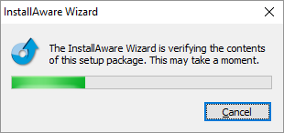

Click Next and continue through the steps via the installation wizard to complete the setup. MLS recommend that the default options are chosen.
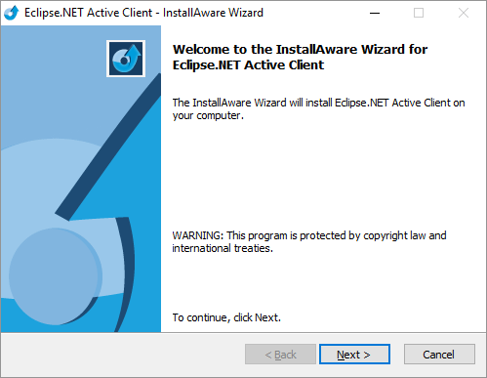

Step 3 – Confirming the installation
Once the installation wizard has completed (this could take a few minutes) some new icons will be added to the Desktop and / or Windows Task Bar. There will be 2 or 3 icons, depending on whether the Secondary / FE or Primary CloudActive package was installed.

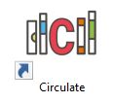Circulate – Opens the Secondary / FE Circulate screen
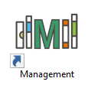 Management – Opens the Library Management screen
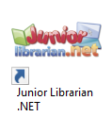Junior Librarian .net – Open the Junior Circulate screen

Step 4 – Configuring the application
Once the CloudActive package is installed click on the Management link (from the Desktop or Windows Task Bar).
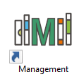

It will then launch the configuration screen and prompt for the login detail:
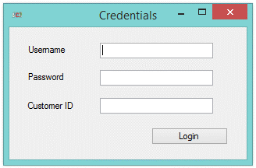

Username – Enter the Administrator account (or any other administrator level account username).
Password – Enter the password for the previously entered account.
Customer ID – Enter the customer ID formatted as U000000, e.g. if the MLS Customer ID is 98765 then the ID to enter would be U098765).
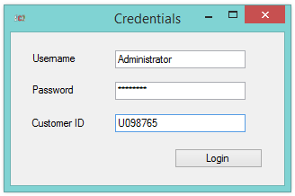

Click Login.
It will then confirm if this was successful.
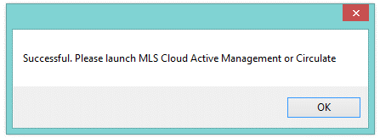
If the system reports that the credentials could not be authorised please check the details entered or contact MLS Support.

Using the system
Once the CloudActive product is installed and configured (as above) the system will automatically launch the relevant section of the application (Circulate / Management / Junior Circulate) when the applicable button is pressed from the Desktop / Windows Task Bar.

Note: The first time after Windows logon / reboot that one of these buttons is pressed it may take a minute to load up, this is because it needs to check the files required to run the package are downloaded and from the latest version. Subsequent launches will be instantaneous.

To start using the system click the Management button:
This will open up the Management portal for the library system.
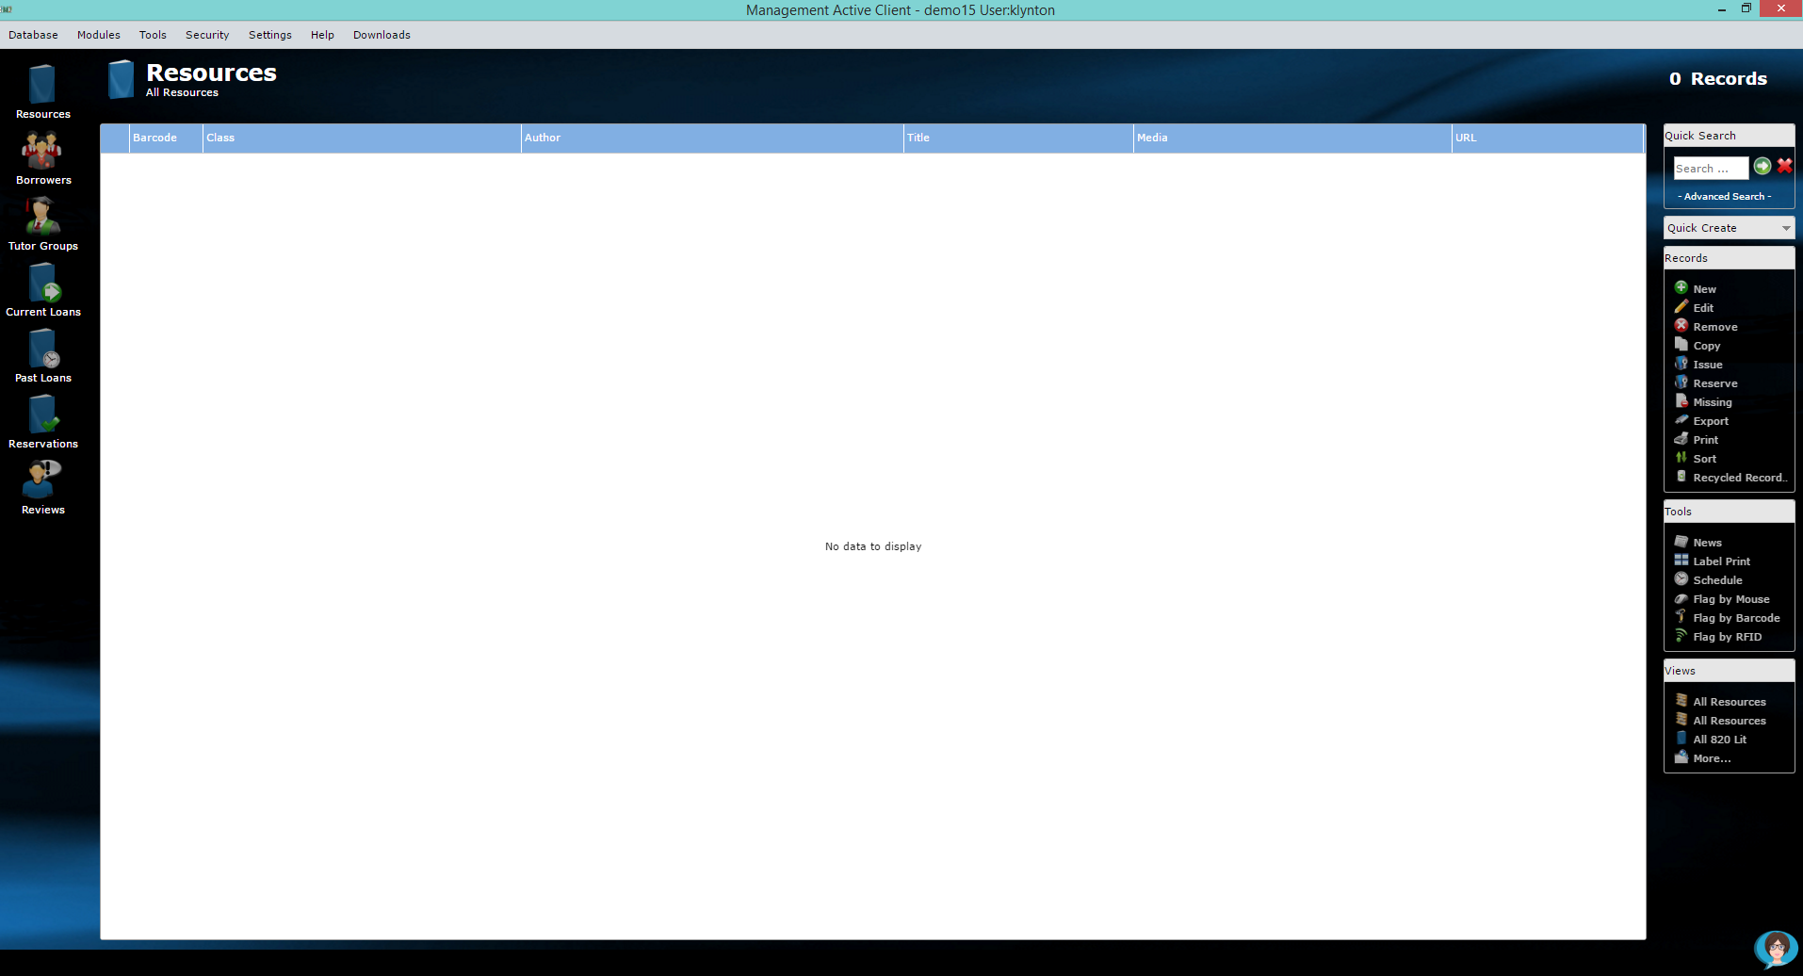
When first opening the system it will either be blank (as no items have been catalogued yet) or show the converted data from the previous library system (if this was requested).

To get started with the system either:
- Click on Help – Help Topics to launch the full user guide
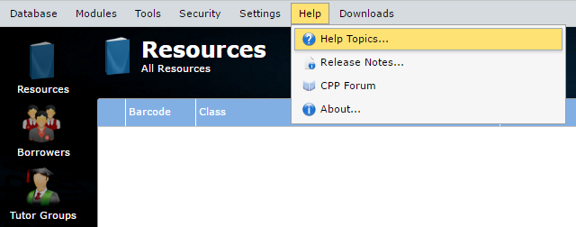

Within the guide there is a full Getting Started section which goes through the process of changing passwords / adding resources / adding borrowers / etc.
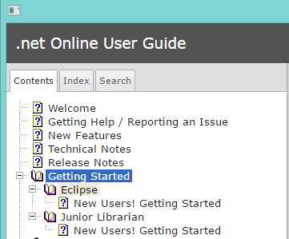

- Ask our virtual assistant Dolores by clicking on the link in the bottom right
Then just ask a question
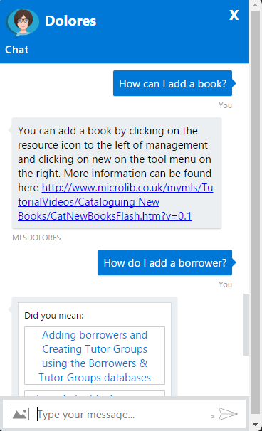

FAQ – Editing the logon / connection details
If for any reason the details entered are saved incorrectly, or the password is changed later, these details can be reset by deleting the configuration file saved locally on the PC.

NOTE: This may require support from the local IT team.

To delete the file:
- Browse to the Roaming profile folder for the user (usually located in C:\Users\{Username}\AppData\Roaming)
- Rename or delete the activeclient.config file.
- Make sure the Management.exe, Junior.exe and Circulate.exe process are closed, or reboot.
- Open the Management link
- It will now prompt for the details again. Re-enter the details as per Step 2 in this document.

